News Tape Documentation

Data Base structure.

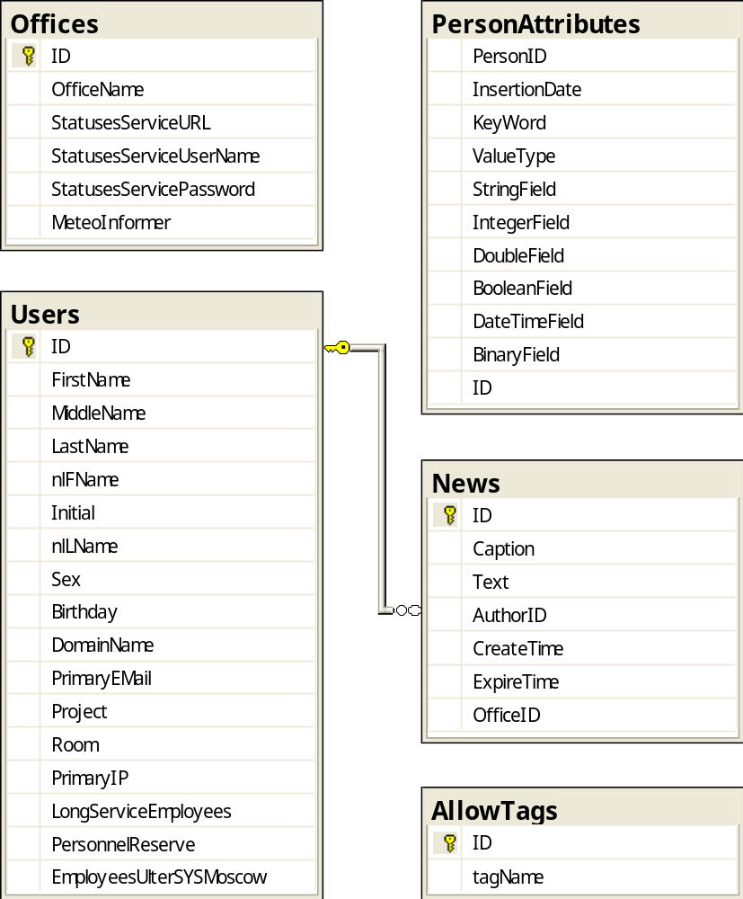

Tables

News
contains information about all the news.
ID (int, ident.) – news identifier;
Caption (nvarchar(MAX)) – news caption;
Text (nvarchar(MAX)) – news text;
AuthorID (int) – news author identifier;
Time (DateTime) – date and time when the news was added;
ExpireTime (DateTime)– date and time when the news becomes obsolete;
OfficeID (int) – identifier of the office this news belongs to;

AllowTags
contains names of HTML- tags which can be included in the news text.
ID (int, ident.) – tag identifier;
tagName (nvarchar(MAX)) – name of allowable tag.

2. Business logic classes structure.

PortalLib.News
news class.
Inherits:
Core.BasePlainObject
Fields:
m_caption (String) – news caption;
m_text (String) – news text;
m_author (String) – news author;
m_time (DateTime) - date and time when the news was added;
m_expireTime (DateTime) - date and time when the becomes obsolete;
m_officeID (int) –ID of the office this news belongs to;
m_officeName (String) – name of the office this news belongs to.

Properties:
Caption (String) – news caption;
Text (String) – news text;
Author ( String) – news author;
CreateTime (DateTime) - date and time when the news was added;
ExpireTime (DateTime) - date and time when the becomes obsolete;
OfficeID (int) –ID of the office this news belongs to;
OfficeName (String) – name of the office this news belongs to;
Methods:
- News () – constructor;
- News ( string caption,
string text,
string author,
DateTime time,
DateTime expTime,
Int officeID) – constructor;
Using:
This class is general class for the News Tape business logic.

PortalLib.NewsCollection
news collection class.
Inherits:
Core.BaseObjectCollection<News>
Using:
This class is usually used for the return type of NewsManager class methods.

PortalLib.NewsManager
class contains methods for operation with news.
Methods:
- static NewsCollection GetActualNews(int personID) – returns collection of actual news for the user specified by personID;
- static NewsCollection GetArchiveNews(PagingArgs args, int personID) - returns collection of full archive news for the user specified by personID;
- static NewsCollection SearchNews(
PagingArgs args,
String searchTerms,
int searchAuthorID,
NewsStatus newsStatus,
int personID,
int officeID,
SearchPeriod period) – returns collection of news that were found for user request;
- static int[] GetUserOfficesIDs(int personID) – returns an array of office IDs for the user specified by personID;
- static string[] GetUserOfficesStringIDs(int personID) – returns an array of office names for the user specified by personID;
- static string TextFormatting(string str) – returns a string, where all signs of new line are replaced with tag <BR> .
- static bool securityCheckNews (News n, out string notAllowedTag) – checks the text of news n for dangerous html-tags. Returns false if the text of the news n contains some dangerous tags. The first such tag returns with notAllowedTag. Returns true if text is not dangerous.
- static ArrayList GetAllowTags() - – returns a list of allowable tags;

Using:
This class is usually used to get functionality of DBManager class.

PortalLib.DBManager
contains methods for operations with data base.
Methods:
Methods for working with news:
- static DataSet GetActualNews(string[] offices) – returns dataset of actual news for the specified offices;
- static DataSet GetArchiveNews(PagingArgs args, out int total_count, String[] offices) - returns dataset of full archive news for the specified offices;
- static DataSet GetNewsEditors() – returns dataset of all news editors.
- static DataTable GetAllowTags() – returns a datatable contains allowable tags.
- static DataSet SearchNews(
PagingArgs args,
out int total_count,
string searchTerms,
int searchAuthorID,
NewsStatus newsStatus,
int officeID,
string[] offices,
SearchPeriod period) – returns dataset of news that were found for user request.
Enumerators:
- public enum NewsStatus
{
AllNews = 0,
ActualNews = 1,
ArchiveNews = 2
} – news status.
- public enum SearchPeriod
{
All = 0,
Day = 1,
ThreeDays = 2,
Week = 3,
Month = 4,
HalfYear = 5,
Year = 6
} – periods for news search.
Using:
This class is usually used to cooperate with data base.

User interface.

User controls
Announce.ascx – user control that is used to show News Tape announce. It contains:
- headers and dates of actual news;
- hyperlink on the full News Tape;
- hyperlink on the page with archive news;
- hyperlink on the page of creating a news (this link is visible only for news editors)
Using:
This control is used on the home page.
Example:
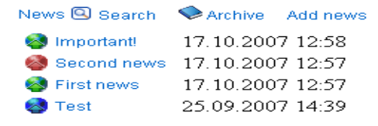
FullNews.ascx – user control that is used to show information about single news. It contains
- news header;
- news text;
- news author;
- news date;
- image that indicates news type;
- hyperlink for deleting this news;
- hyperlink on the page of editing a news (this link is visible only for news editors)
Properties:
- UlterSystems.PortalLib.BusinessObjects.User CurrentUser – current user;
- bool IsInPreviewMode – is control in preview mode. It affects visibility of links (Edit, Send to Archive, Delete);
- bool IsInFullHeightMode – is control in full mode. If it is, an area that shows news text has no height limit;
- News CurrentNews – current news;
- int NewsID – current news identifier;
Using:
This control is used on the FullNewsTape, Preview, ViewNews pages.
Example:
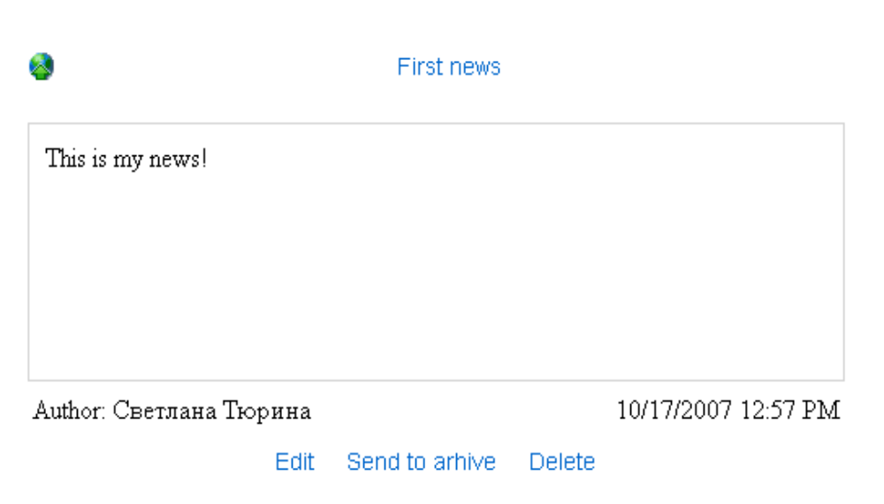

Pages

BaseNewsPage – base class for pages that use current news and news identifier.
Inherits:
BaseWebPage
Properties:
- News CurrentNews - current news;
- int? NewsID - current news identifier;

Default.aspx – shows only news announce.
Example:
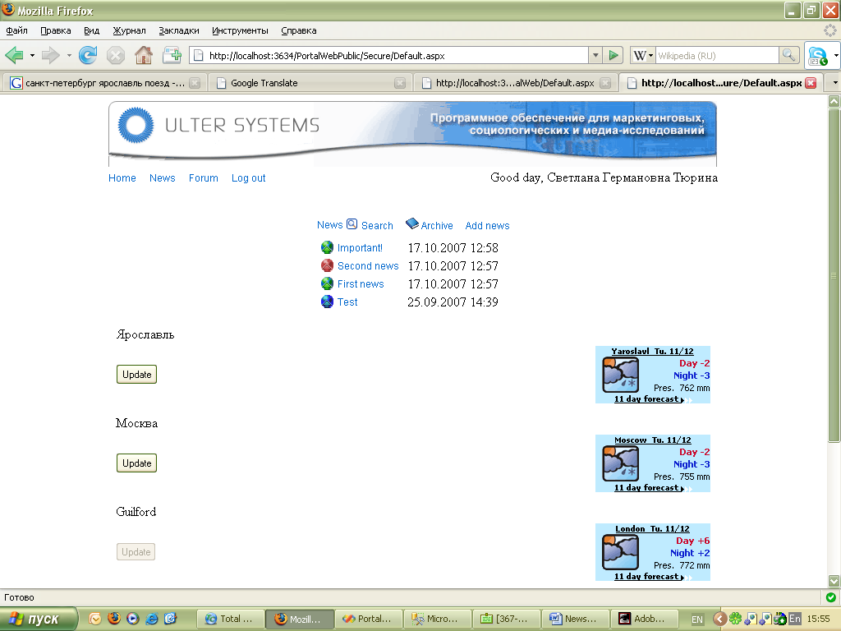

FullNewsTape.aspx – shows full news tape.
FullNews controls aren’t in full height mode.
FullNews control isn’t in preview mode.

Inherits:
BaseWebPage

Example:
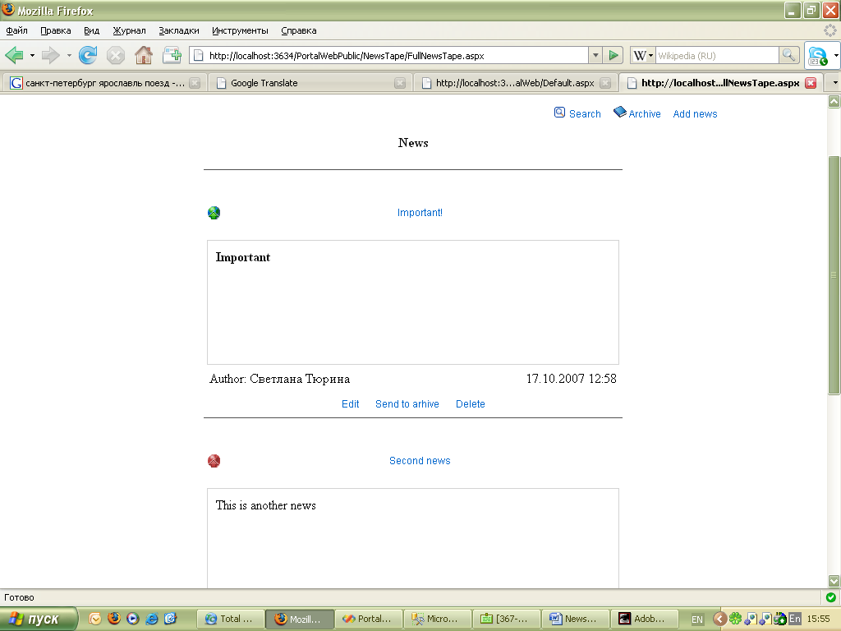

AddNews.aspx – page used for creating and editing news.
Inherits:
BaseNewsPage
Example:
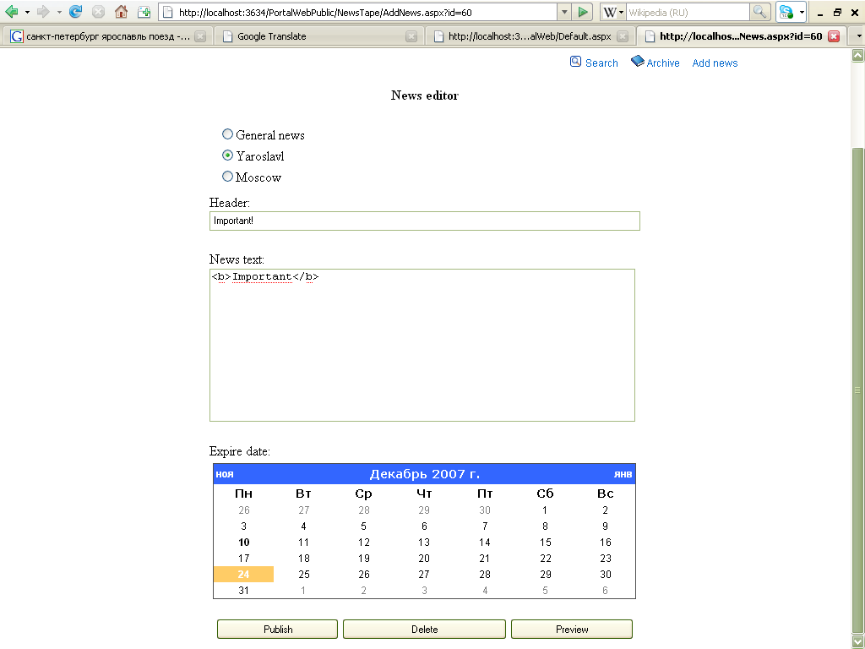

Archive.aspx – shows announce of archive news.

Inherits:
BaseWebPage

Example:
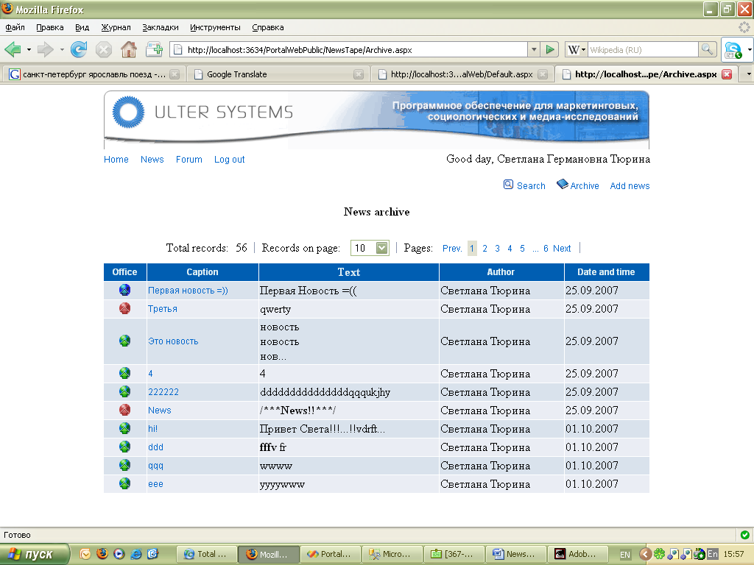

Preview.aspx – shows the news in preview mode.
FullNews control is in full mode.
FullNews control is in preview mode.

Inherits:
BaseNewsPage

Example:
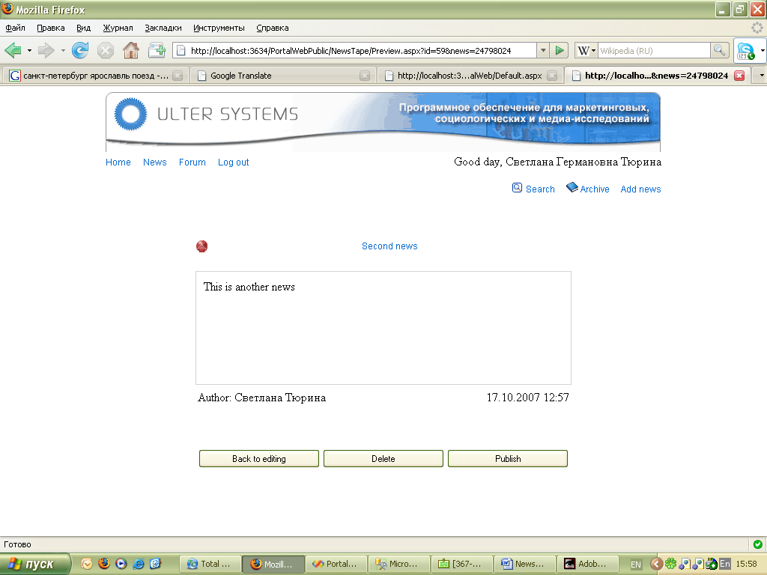

ViewNews.aspx – shows the full news.
FullNews control is in full mode.
FullNews control is in preview mode.

Inherits:
BaseNewsPage

Example:
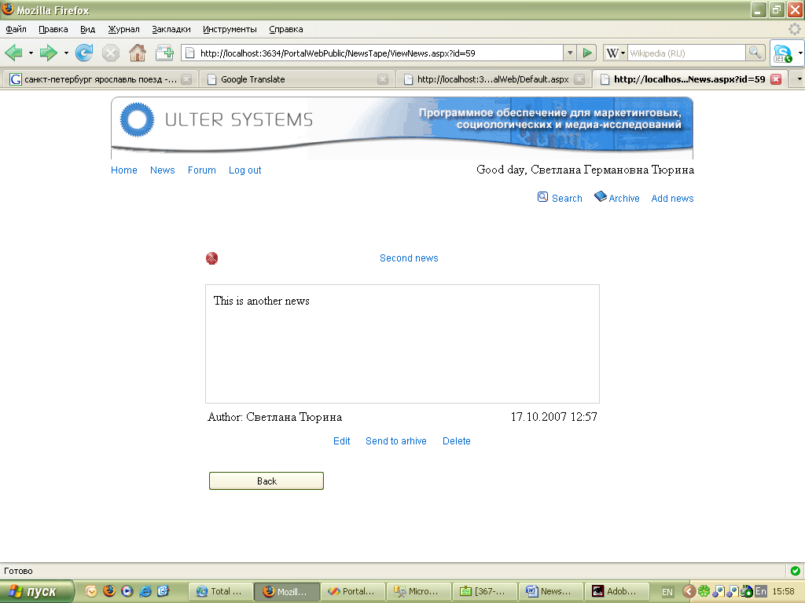
SearchNews.aspx – page for news search.
Here user can add parameters for search and sort results by different columns. User can also choose number of news showing on the page.
Inherits:
BaseWebPage
Example:
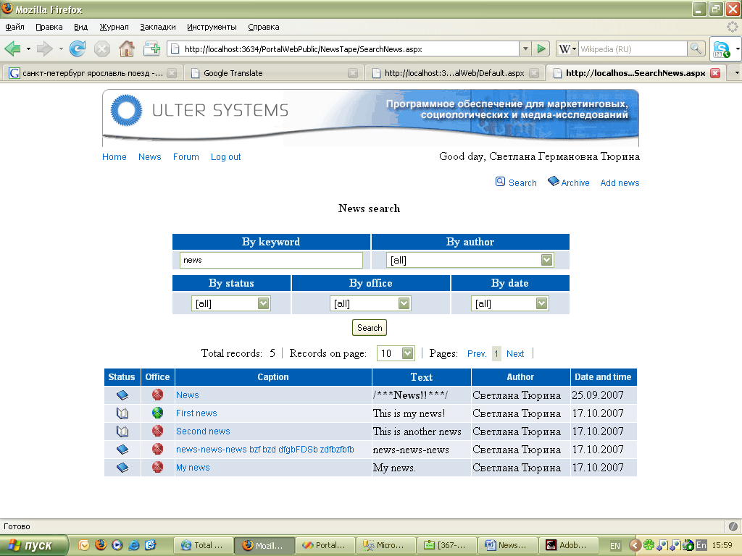

AccessViolation.aspx – page showed when user tries to edit or delete the news that he hasn’t created.

Inherits:
BaseWebPage

Example:
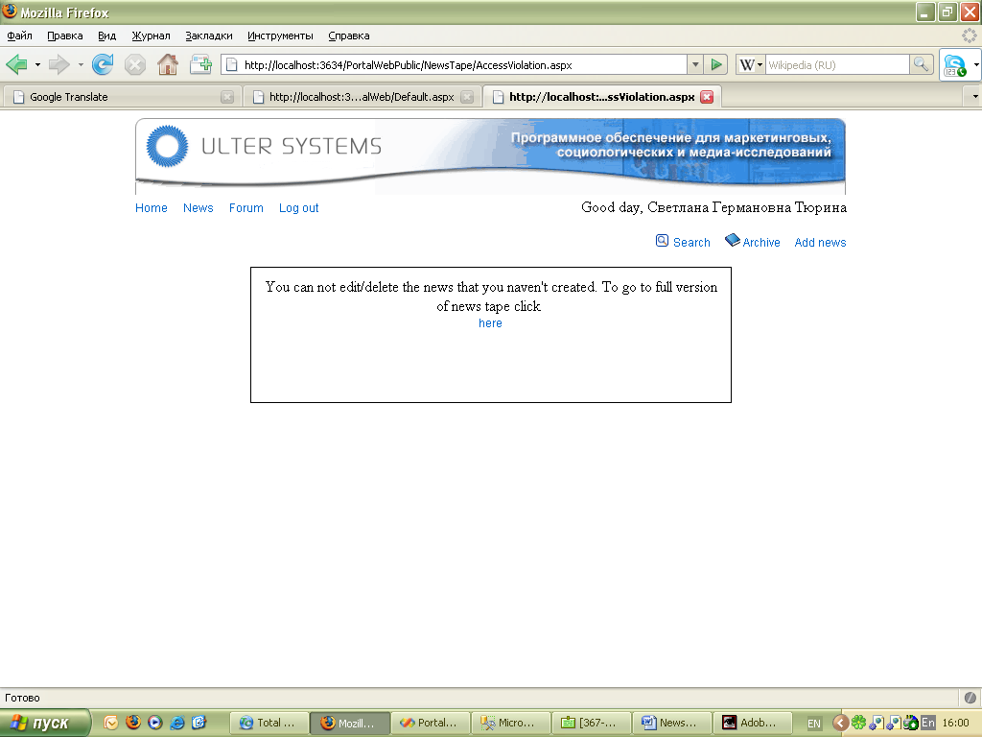

AccessDenied.aspx – page showed when user tries to edit or delete the news that he hasn’t created.

Inherits:
BaseWebPage

Example:
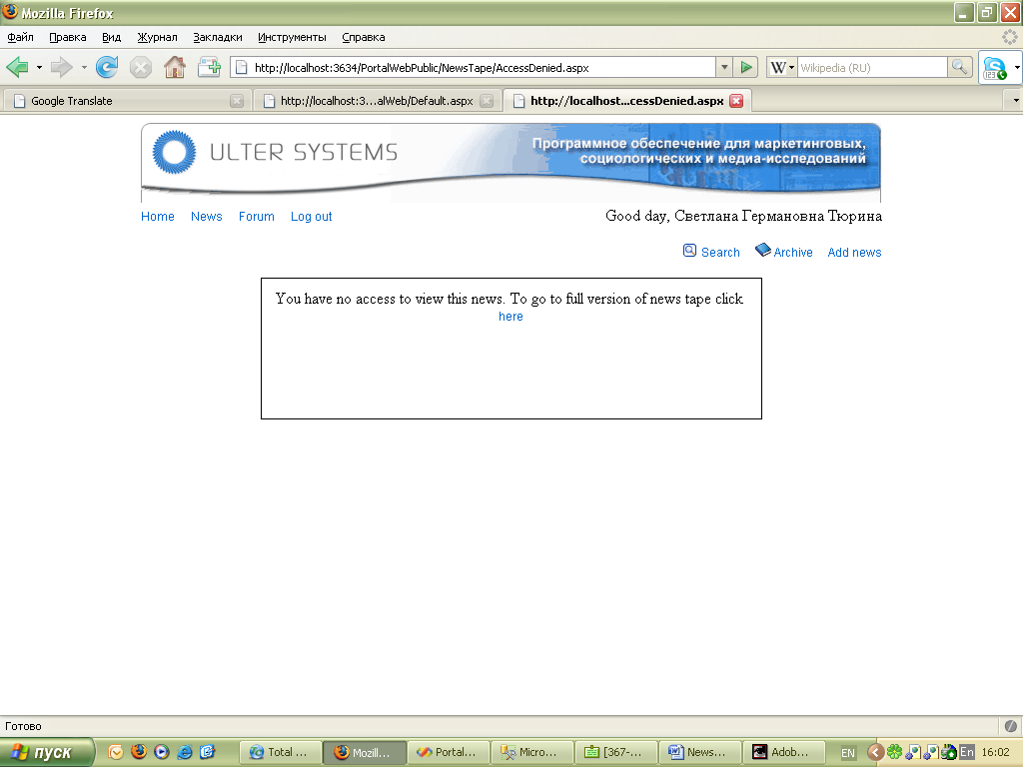

User guide.

Users rights

- All the users have rights on reading news.
- News editors have rights on creating news, editing their news, deleting their news, send news to archive, restore their news from archive. If user tries to edit or delete the news created by someone else he would be redirected on the AccessViolation page.

Action order
- To view full news tape click “News” hyperlink on Home page.
- To view archive news click “Archive” hyperlink on Home page.
- To view single news click it’s header on Home page, FullNewsTape page or Archive page.
- To create the news you should follow link “Add news” on the Home page.
On the AddNews page you should enter news header, news text, select office and expire date in the calendar.
You may preview your news.
To publish your news you should click “Publish” button on the AddNews page or Preview page.
- To edit the news you should click “Edit” hyperlink on FullNewsTape page or “Edit” button on ViewNews page. Look item 1.
- To send news to archive you should click “Send to archive” hyperlink on FullNewsTape page or “Send to archive” button on ViewNews page. Look item 1.
- To delete the news you should click “Delete” hyperlink on FullNewsTape page or “Delete” button on AddNews page.
- To restore the news from archive you should choose this news in archive and click “Edit” hyperlink on ViewNews page. Look item 1.

Note

Public Web Portal provides the same actions with news tape.

